String handling in Java is a fundamental concept that involves working with strings, which are sequences of characters. Java provides the String class and other related classes in the java.lang package to perform various operations on strings. Here's an overview of key aspects of string handling in Java:

1. Creating Strings
Strings in Java can be created in two ways:
- Using String Literals:
- String str1 = "Hello, World!";
- Using the new Keyword:
- String str2 = new String("Hello, World!");

2. Common String Methods
Java's String class provides many methods for string manipulation:
- Length of a String:
- int length = str1.length();
- Concatenation:
- String result = str1.concat(" How are you?");
- Can be done using + operator also
- Character at a Specific Index:
- char ch = str1.charAt(0); // 'H'
- Substring:
- String sub = str1.substring(7); // "World!"
- String Comparison:
- boolean isEqual = str1.equals(str2); // true or false
- int comparison = str1.compareTo(str2); // 0 if equal, >0 or <0 otherwise

Key Takeaway:
- Use equals() to compare the values of strings.
- Use == to check if two string references point to the same object in memory //object memory reference

- Case Conversion:
- String upper = str1.toUpperCase();
- String lower = str1.toLowerCase();
- Trim Whitespace:
- String trimmed = str1.trim();
- trim() removes spaces, tabs, and other whitespace characters from the beginning and end of the string.
- Replace Characters:
- String replaced = str1.replace('o', 'a'); // "Hella, Warld!"

3. String Immutability
Strings in Java are immutable, meaning their value cannot be changed once created. Any modification creates a new string object. For example:
String original = "Java";
String modified = original.concat(" Programming");
// `original` remains "Java", while `modified` is "Java Programming".

4. StringBuilder and StringBuffer
For mutable strings (strings that can be modified), Java provides:
StringBuilder (not thread-safe but faster):
- StringBuilder sb = new StringBuilder("Hello");
- sb.append(" World!");
- System.out.println(sb); // "Hello World!"
StringBuffer (thread-safe but slower):s
- StringBuffer sbf = new StringBuffer("Hello");
- sbf.append(" World!");
- System.out.println(sbf); // "Hello World!"

5. Splitting and Joining Strings
- Splitting Strings:
- String[] parts = str1.split(", ");
- Joining Strings:
- String joined = String.join(" ", "Hello", "World!");

6. String Formatting
You can format strings using String.format():
String formatted = String.format("Name: %s, Age: %d", "Alice", 25);

7. Checking String Properties
- Starts or Ends With:
- boolean starts = str1.startsWith("Hello");
- boolean ends = str1.endsWith("World!");
- Contains Substring:
- boolean contains = str1.contains("World");

8. Converting Strings
- To Integer:
- int num = Integer.parseInt("123");
- To String:
- String str = String.valueOf(123);
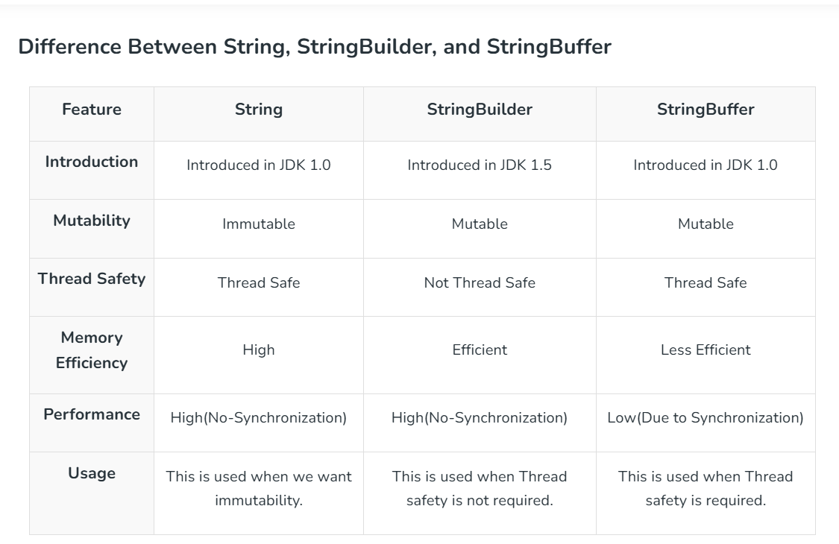

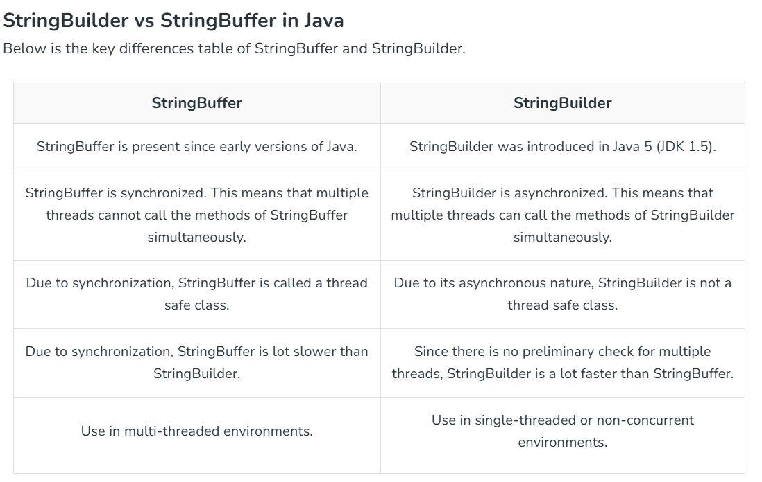

Conversion Between Types of Strings in Java
- From String to StringBuffer and StringBuilder
ècreate string buffer and builder object then pass the string as argument
- From StringBuffer and StringBuilder to String
èuse tostring() Method
- From StringBuffer to StringBuilder or vice-versa
èfirst convert into string using toString() then pass that string as argument to required type.
Summary
- String: Stored in the String Pool, immutable.
- StringBuffer: Stored in the heap, mutable, synchronized.
- StringBuilder: Stored in the heap, mutable, not synchronized.

